GRP Intess Telco Graphene Power

Introducing the GRP Intess Telco Series: Revolutionary Graphene Power Batteries with Integrated Smart Battery Management, Engineered by GRP Battery.
The Intess Telco graphene power battery heralds a groundbreaking leap in energy storage technology, meticulously designed for the precise needs of base stations and data warehouses. This exceptional battery capitalizes on the incredible properties of graphene to deliver an uninterrupted power supply for all your BTS equipment and server systems.
With its remarkable fast-charging capabilities, the Graphene Power battery guarantees constant backup power, even in the face of volatile grid conditions. A quick recharge during brief breaks is all it takes to keep your equipment running smoothly throughout the day, eliminating the need for additional backup batteries or backup generators.
In contrast to traditional lead-acid or lithium batteries, the Graphene Power Battery offers substantial benefits. It is notably lighter, boasts an extended lifespan of up to 20,000 cycles, and is accompanied by an impressive 15-year warranty. Furthermore, it demands no maintenance, presenting a hassle-free solution for your energy storage requirements.
GRP offers a comprehensive range of graphene power batteries, accommodating diverse equipment sizes and voltage specifications:
- Voltage Range: 12 to 48 Volts
- Power Output: 10 to 2MW
Each variant of the Intess Telco Graphene power battery is designed to seamlessly integrate into a standard 19” rack, eliminating the need for additional battery compartments.
The GRP Intess Telco Graphene battery stands as the ultimate solution to guarantee uninterrupted and enduring equipment operation, establishing new benchmarks for efficiency and reliability in the industry.

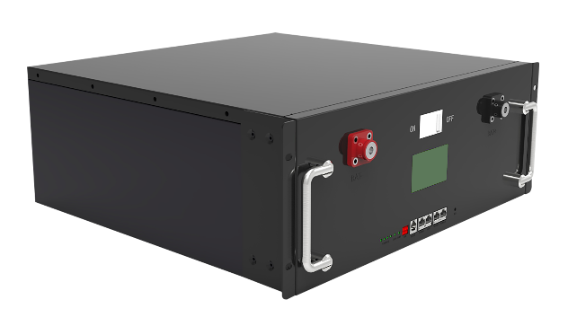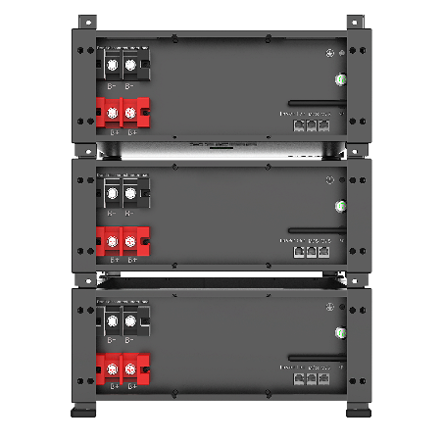

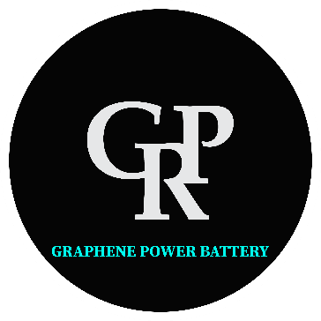

SUPER CAPACITOR MODULE TECHNICAL DATA SHEET
Part Number: SY48V5KWh50E | Version Date: April 2023

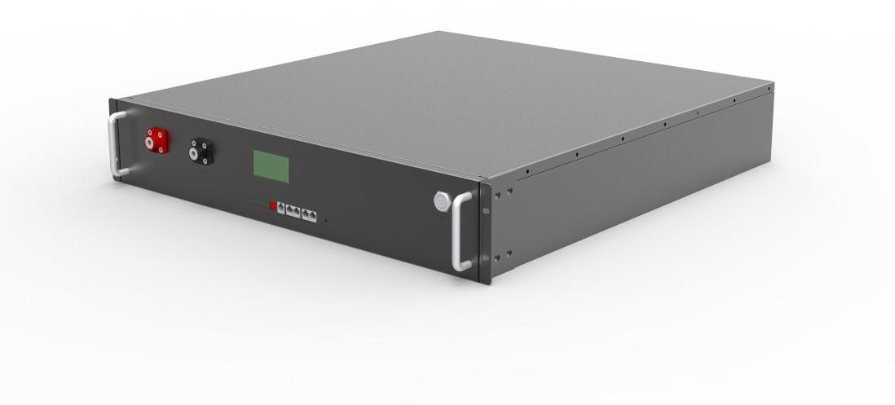

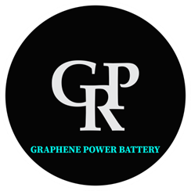

Scope
This Specification is applied to Super capacitor Battery Pack manufactured for GRP Battery.

Ratings

Part Number |  | SY48V5KWH50E | Remark
Nominal Capacity |  | 100Ah | ±5% @25℃
Nominal Voltage |  | 51.2V | ---
Nominal Energy |  | 5.12Kwh | ---
Upper volatge |  | 57.6V
Low voltage |  | 41.6V
Pack resistance |  | < 50 mΩ | @ 1KHz AC，50% SOC
Max. Continuous Charge |  | 100A
Max. Continuous Discharge |  | 100A
Peak dis current |  | 120A | ：@50%soc ，10s
Weight |  | 45kg
Projected Cycle Life ( 25℃) |  | 20,000 times
Warranty |  | 15 years
Self-discharge Rate |  | 2% per month
Cooling |  | Natural cooling
Case material |  | Steel case
Storage Temperature |  | -20℃~40 ℃ | SOC>30%，one full charge needed per two months
Storage Humidity |  | 25% ~ 95%RH | ---
Operating Temperature | Discharge | "-20 ℃~60 ℃ | ---
 | Charge | 0 ℃~55 ℃ | ---
Dimension（mm） |  | 560*730*133

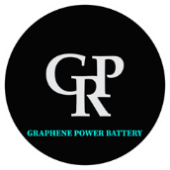

- System electrical diagram

The system is function modularity design.

- The interface of charge and discharge is integrated.

- The cell voltage and battery temperature is detected by BMS.

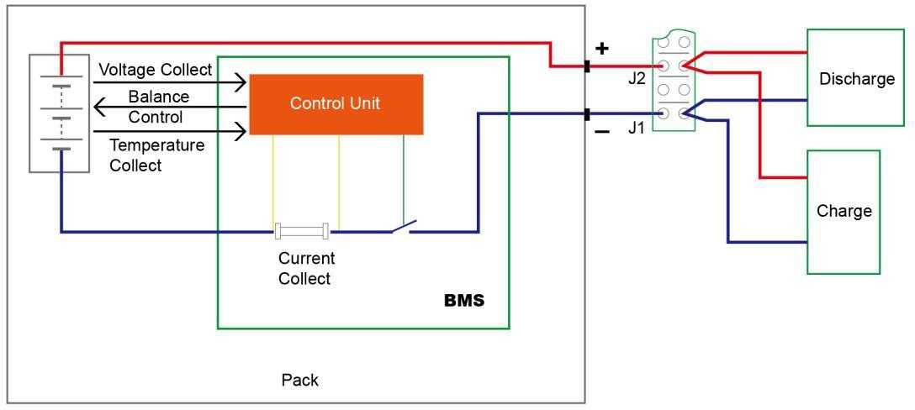

Caution
  - Place the battery out of the reach of children and infants.
  - Do not place the battery in microwave ovens or other similar appliances.
  - Do not remove the product label.
  - Do not attempt to open or service the battery pack.
  - Do not expose to temperatures above 80oC.
  - Do not short-circuit the positive and negative terminals of the battery with wire or other metallic objects. Do not transport or store the battery with metallic items.
  - Do not expose the battery to direct heat or flame, and do not use or store it near a fire or a location, subject to high temperatures. In addition, do not immerse or dampen the battery in water, saltwater, or any other liquid.
  - Do not puncture the battery with any sharp objects, hit it with a hammering device or similar device, step on it, drop it or subject it to strong shock.
  - Do not use battery if it is damaged or deformed.
  - Immediately cease use of the battery if it produces strange smells or smokes or becomes abnormally hot.
  - If the battery fluids leak and come into contact with an eye, do not rub the eye and immediately flush it with plenty of water before seeking medical assistance.

