GRP Intess Residential Energy Storage system

Introducing the GRP Intess Series: Graphene Power Batteries Enhanced with Smart Battery Management.

The Intess residential graphene power battery is designed specifically for efficient in-house energy storage. Harnessing the power of graphene, this battery system excels at capturing and preserving solar energy while complementing it with grid power when needed, all at the lowest possible cost.

Our Intess mobile app takes charge of regulating the charging and discharging processes, intelligently responding to cost-effective tariff options. As a result, customers can expect a substantial reduction in their electricity expenses. Additionally, any surplus energy stored at lower rates can be sold back to the energy provider for a higher return.

Within the GRP Intess Series, we offer two distinct models of graphene power batteries: the wall-mounted option and the versatile mobile stackable model. Both models boast storage capacities ranging from 5KW to an impressive 30KW. Furthermore, our comprehensive system includes a hybrid inverter and an advanced Battery Management System, ensuring seamless and efficient operation.

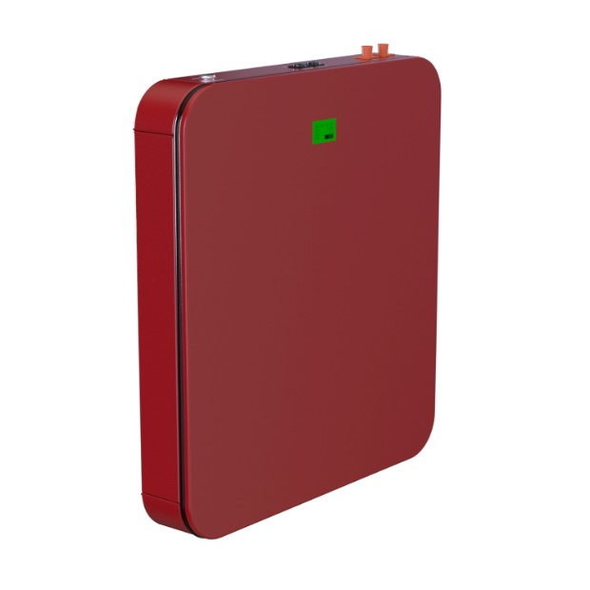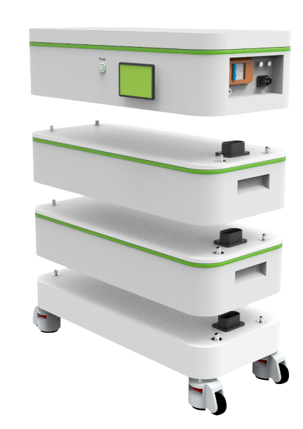

INTESS
Intelligent Energy Storage System

SUPER CAPACITOR MODULE TECHNICAL DATA SHEET
Part Number: SY51.2V6KWh-60KWh31H | Version Date: April 2023

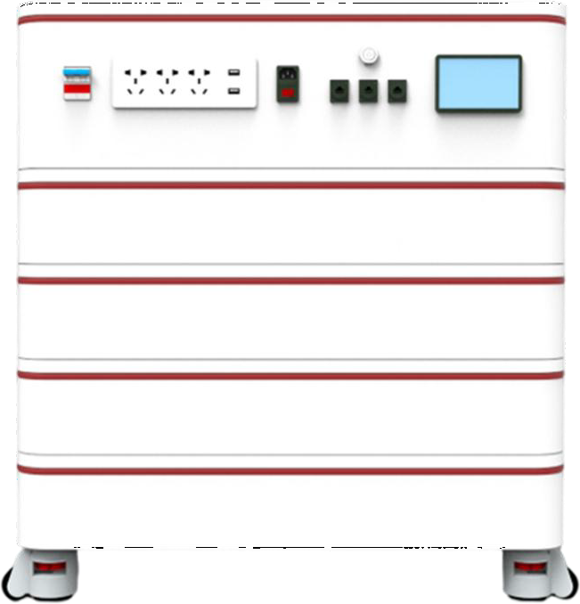
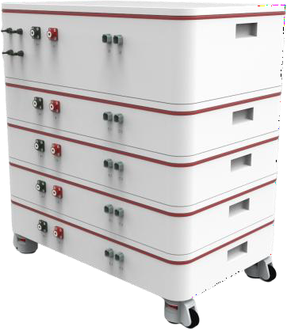

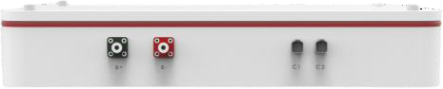
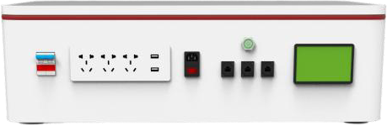

Standard Module Inverter module (Optional)

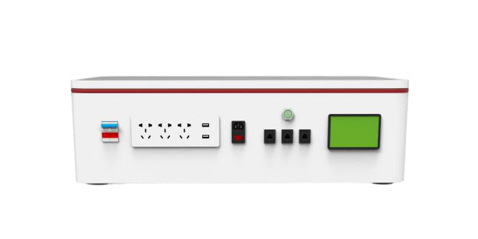
Scope

This Specification is applied to Super capacitor Battery Pack manufactured by GRP Battery.

One-Stop Stackable Power Bank

One-Stop Stackable power bank is for residential or light commercial use. It is flexible from 6Kwh to 60Kwh configuration.

One-Stop power bank’s electrical interface provides a simple connection to Load, 5Kw Inverter module is optional for customers. Compact design and flexible configuration lead it to market-leading products.

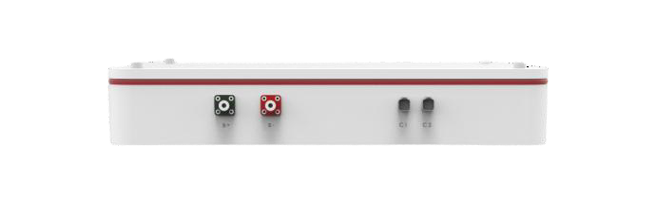
Performance specifications

Standard Module
Total Energy | 6Kwh/120Ah
Usage Energy | 5.85Kwh
Nominal Voltage | 51.2V
Charging/Discharging power | 5Kw
Upper voltage | 57.6V
Low voltage | 44.8V
Cycle life | 20000cycles/80%DOD
Warranty | 15 years
Self-discharge Rate | 2% per month
Cooling | Natural cooling
Temp Range/Discharging | -30~55℃
Temp Range/Charging | 0~55℃
Storage Humidity | 5~95%
Communication Port | CAN/485
Support Parallel Number | 10
Inverter Module (Optional)
Rated power | 5Kw
AC voltage （Input/Output） | 220V-230V-240V
USB (5V) | Yes
MC4 Connector | Yes
DC Breaker | Yes
Waveform | Pure Sine Wave
Operating voltage MPPT range | 120~430VDC
WIFI | Optional

Caution
  - Place the battery out of the reach of children and infants.
  - Do not place the battery in microwave ovens or other similar appliances.
  - Do not remove the product label.
  - Do not attempt to open or service the battery pack.
  - Do not expose to temperatures above 80oC.
  - Do not short-circuit the positive and negative terminals of the battery with wire or other metallic objects. Do not transport or store the battery with metallic items.
  - Do not expose the battery to direct heat or flame, and do not use or store it near a fire or a location, subject to high temperatures. In addition, do not immerse or dampen the battery in water, saltwater, or any other liquid.
  - Do not puncture the battery with any sharp objects, hit it with a hammering device or similar device, step on it, drop it or subject it to strong shock.
  - Do not use battery if it is damaged or deformed.
  - Immediately cease use of the battery if it produces strange smells or smokes or becomes abnormally hot.
  - If the battery fluids leak and come into contact with an eye, do not rub the eye and immediately flush it with plenty of water before seeking medical assistance.

Notes
  - The pictures in the file are only for reference.
  - We reserve the final explanations of the items in this specification. This proposal is applicable for prototype.

