GRP Intess Mega Graphene Power system

1. INTRODUCTION
1.1. PURPOSE OF THIS DOCUMENT
This document serves as an overview of the GRP Graphene Power 40MWh 20MVA Battery Energy Storage System (BESS) design. It provides comprehensive technical specifications and functional details of its components.
1.2. SCOPE OF THIS DOCUMENT
This document encompasses critical aspects of the battery energy storage system, including system performance, installation procedures, necessary inputs, monitoring and control mechanisms. All information contained herein pertains specifically to grid-tied energy storage configurations and applications.
1.3. GENERAL DESCRIPTION
The system is engineered for energy storage, employing Super Capacitor battery cells. Its array configuration ensures operational versatility and system reliability. The Battery Management System (BMS) plays a pivotal role in monitoring and balancing all cells, prioritizing system safety.
At the heart of the system lies the Site Controller, functioning as the central control hub responsible for orchestrating interactions between the BESS and the electric power grid. It encompasses control, protection, management, optimization, and various communication devices and modules.
Additionally, a utility-grade Supervisory Control and Data Acquisition (SCADA) system is integrated. The SCADA platform delivers dependable data acquisition, supervisory and remote control capabilities, real-time and historical database maintenance, reporting functionalities, energy accounting features, and user-customizable Human Machine Interfaces (HMIs).
1.4. INTENDED USE
The system is intended for operation solely with the provided GRP Site Controller and BMS system. All components are enclosed in outdoor-rated enclosures and should be installed in locations approved by GRP. Operating the components in a manner or at locations not explicitly sanctioned by GRL will result in the forfeiture of any warranties.
2. BATTERY CELL
At the core of the system lies the fundamental building block, the 31Ah Super Capacitor battery cell (refer to Figure 1). In comparison to similar products, GRP's Super Capacitor cell stands out with superior performance and an extended cycle life.

2 MWh-1MWh-500Kwh
Supercapacitor battery Energy Storage System
Specification Document

Revision 1.0
September 3, 2023

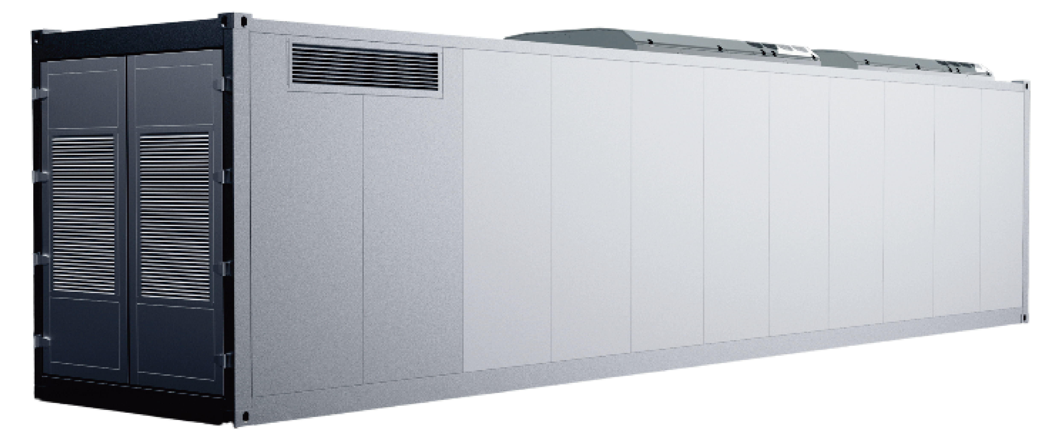

Table 1: Basic Parameters of Battery Cell
Battery Cell Technical Parameters
Battery Model | DBF031PA
Rated capacity (Ah) | 31
Rated voltage (V) | 3.2
The operating voltage range (V) | 2~3.65
Dimensions (mm) | T9.9 (±0.2) * W309 (±1) * H103 (±2)
Weight (g) | 620 (±10)

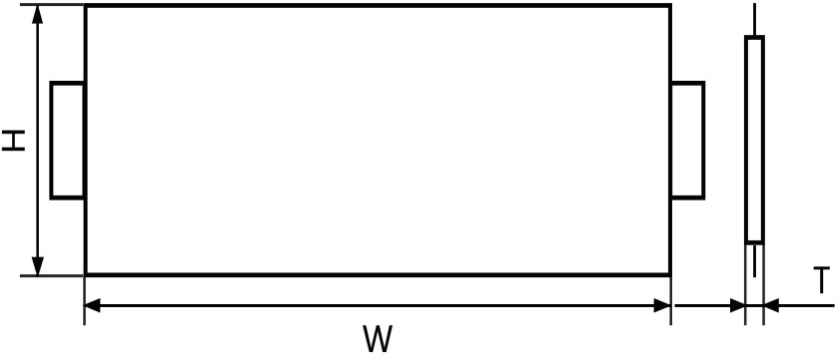

FIGURE 1: CELL DIMENSIONS

GRP BATTERY’s Supercapacitor battery cells are designed for extremely high cycle life, exceeding 20000 cycles at 80% depth of discharge. GRP BATTERY’s vertically integrated cell manufacturing operations provide complete control of product quality. In house production & technology development includes: both-electrodes, electrolyte, separator, and full cell construction.

