GRP Intess Marine Graphene Power

Introducing the GRP Intess Marine Series: Revolutionary Graphene Power Batteries Enhanced with Smart Battery Management, Engineered by GRP Battery.
The Intess Marine graphene power battery represents a quantum leap in energy storage technology, meticulously crafted to cater to the specific demands of yachts and vessels. This exceptional battery harnesses the extraordinary capabilities of graphene to provide a continuous and reliable power source for all your onboard equipment.
With its exceptional fast-charging capabilities, the Graphene Power battery ensures a consistent supply of backup power. A brief recharge is all it takes to keep your equipment operating seamlessly throughout the day.
In stark contrast to conventional lead-acid or lithium batteries, the Graphene Power Battery offers significant advantages. It is notably lighter, boasts an extended lifespan of up to 20,000 cycles, and comes with an impressive 15-year warranty. Moreover, it requires no maintenance, presenting a hassle-free solution for your energy storage needs.
GRP offers an extensive selection of graphene power batteries, catering to various equipment sizes and voltage specifications:
- Voltage Range: 12 to 48 Volts
- Power Output: 10 to 60KW
Installing the Intess Marine graphene battery in your yacht or vessel is a straightforward process. It includes an integrated inverter to meet your power requirements seamlessly. Additionally, the battery management system effortlessly integrates with solar energy panels, providing a comprehensive energy solution.
The GRP Intess Marine Graphene battery stands as the ultimate solution to ensure uninterrupted and enduring equipment operation, setting new standards for efficiency and reliability in the maritime industry.



SUPER CAPACITOR MODULE TECHNICAL DATA SHEET
Part Number: 25.6V30KWH | Version Date: September 2023

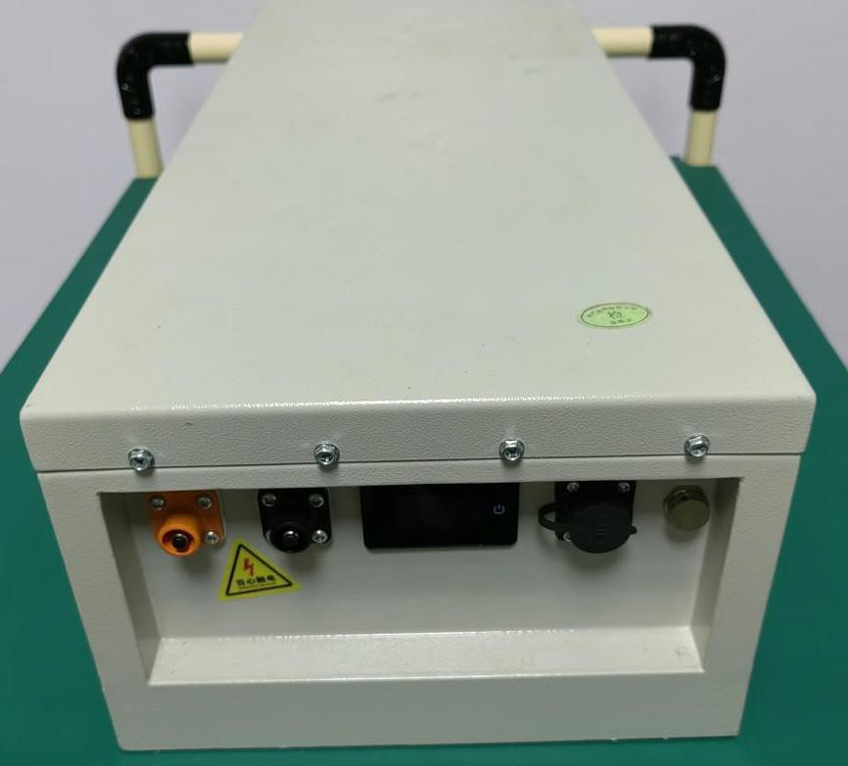

Part Number | 25.6V30KWH
Usable Energy | 30KWh
Cell Type | super capacitor battery
Rated Voltage | 25.6V/DC
Maximum Charge Voltage | 29.2V/DC
Discharge Cut-off Voltage | 20.5V/DC
Dimensions (WxDxH) | 920×480×390mm
ESR/AC @1KHz | <10mΩ
Max. Continuous Charge Current | 600A
Max. Continuous Discharge Current | 1200A
Weight | 240Kg
Discharge Temperature | -10℃~+60℃
Charge Temperature | 0℃~+65℃
Cooling Method | Natural cooling
Operating Humidity | 0~90% RH Non-condensing
Cells Self-discharge Rate | 2% per month
Projected Cycle Life ( 25℃) | 20,000 times
Recommended Depth of Discharge | ≤ 90%
Maximum Depth of Discharge | 100%
Shell Material | Metal
Monitoring Data | Module voltage,SOC
Shelf Life | 5 years
IP Grade | IP65
Storage Conditions | -10℃~+45℃ 25% ~ 95%RH  SOC>30%，one full charge needed per two months
Certificates Compliant | CE:EN 62133:2013, EN 55032:2015+AC:2016, EN 55035:2017, EN 61000-3-2:2014, EN 61000-3-3:2013

