GRP Forkess Graphene Power

Introducing the GRP Forkess Series: Cutting-edge Graphene Power Batteries with Integrated Smart Battery Management, Engineered by GRP Battery.
The Forkess graphene power battery represents a groundbreaking advancement in energy storage technology, tailored specifically for forklifts and various other machinery vehicles. This remarkable battery harnesses the potential of graphene to provide an uninterrupted power source for all your electric forklifts and similar machinery vehicles.
With its exceptional fast-charging capabilities, the Graphene Power battery ensures minimal equipment downtime. A quick top-up charge during breaks is sufficient to keep your machinery operational throughout the day, eliminating the need for frequent battery swaps or recharge interruptions.
Compared to conventional lead acid or lithium batteries, the Graphene Power Battery offers substantial advantages. It is notably lighter, boasts an extended lifespan of up to 20,000 cycles, and is backed by an impressive 15-year warranty. Plus, it requires no maintenance, providing a hassle-free solution for your energy storage needs.
GRP offers a diverse range of graphene power batteries, catering to various machinery sizes and voltage requirements:
- Voltage Range: 24 to 96 Volts
- Power Output: 10 to 60 KW
The GRP Forkess Graphene battery stands as the ultimate solution to ensure the uninterrupted and long-lasting operation of all your machinery vehicles, setting new standards for efficiency and reliability.

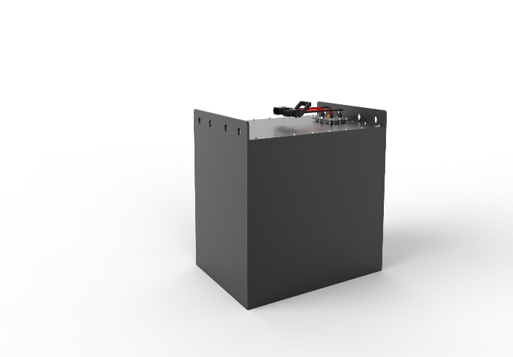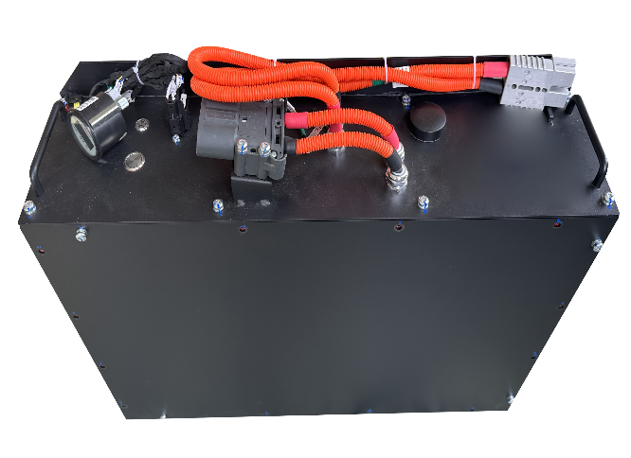



SUPER CAPACITOR BATTERY TECHNICAL DATA SHEET
Part Number: SY48V10KWH21F | Version Date: June 2023

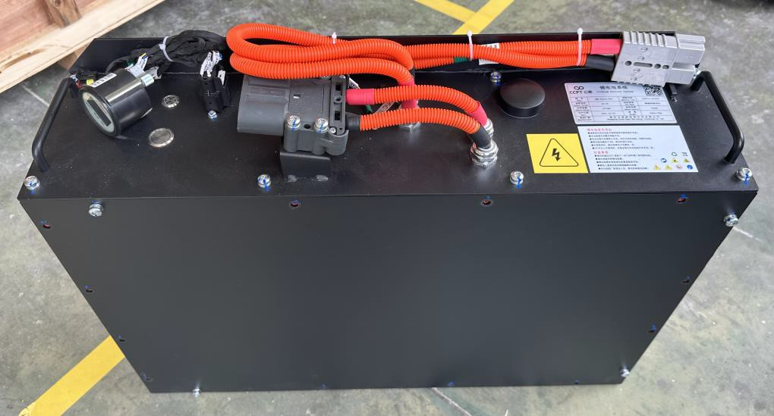



Scope
This Specification is applied to Super capacitor Battery Pack manufactured for GRP Battery.
1. Ratings

NO. | Item |  | Parameter | Remark
1 | Nominal Capacity/Ah |  | 210 | ±5% @25℃
2 | Nominal Voltage/V |  | 51.2 | ---
3 | Nominal Energy/Kwh |  | 10 | ---
4 | Configuration |  | 16S10P | ---
5 | Upper voltage |  | 58.8
6 | Low voltage |  | 39.2
7 | Pack resistance |  | < 50 mΩ | @ 1KHz AC，50% SOC
8 | Continuous Charge |  | 100A
9 | Continuous Discharge |  | 200A
10 | Peak dis current |  | 600 | @ 50% SOC,10S
11 | Weight |  | ~100Kg
12 | Projected Cycle Life ( 25℃) |  | 10000times
13 | Shelf Life |  | 10 years
14 | Cells Self-discharge Rate |  | 2% per month
15 | Cooling |  | Natural cooling
16 | Case material |  | Steel case
17 | Storage Temperature |  | -20℃~40 ℃ | SOC>30%，one full charge needed per two months
18 | Storage Humidity |  | 25% ~ 95%RH | ---
19 | Operating Temperature | Discharge | -20 ℃~60 ℃ | ---
 |  | Charge | 0 ℃~55 ℃ | ---
20 | Dimension（mm） |  | 470*240*660 | could customized

